

**Image And Video Analytics**

**LAB 5**

Name : SRINIVAS REDDY

Reg.no : 21MIA1028

Faculty name : Dr. Saranyaraj D

Date : 23-10-2024

**Objective**

The purpose of this assignment is to investigate a range of image processing techniques, concentrating on the following key areas:

• Face Detection: Implementing Haar Cascade classifiers to recognize faces within an image.

• Gender Classification: Utilizing geometric principles to categorize identified faces as male or female based on their aspect ratio.

• Emotion Recognition: Evaluating facial characteristics to identify emotions (happy, sad, neutral) through pixel intensity analysis in designated areas (such as the mouth).

• Skin Detection: Employing skin-color-based methods to isolate regions of interest (hands and faces) in images.

**Problem Statement**

• Problem Description: The main challenge lies in the precise detection of faces in images and the classification of their corresponding emotions and genders. In scenarios where multiple faces are present, it is crucial to distinguish and categorize them effectively based on attributes such as facial proportions and expressions.

• Expected Output: The anticipated results should encompass:

o An annotated image featuring rectangles around the identified faces.

o Emotion labels positioned above the detected faces.

o A CSV file containing information about the detected faces, including their coordinates, as well as classified emotions and genders.

o A visual representation of the classified gender and identified emotions on the original image.

**Methodology**

• Block Diagram:

Load Image

↓

Convert to Grayscale

↓

Face Detection

↓

Feature Extraction

↓

Emotion Classification

↓

Gender Classification

↓

Output Results

• **Algorithm:**

1. Load the input image.

2. Transform the image to grayscale.

3. Identify faces using Haar Cascade.

4. For each detected face: a. Draw a rectangle around it. b. Crop and normalize the facial region. c. Compute the aspect ratio for gender classification. d. Examine the mouth region for emotion detection.

5. Save the annotated image.

6. Record detected emotions and gender classifications in a CSV file.

7.

• Code Snippets:

if len(detected_faces) > 0:

for (x, y, w, h) in detected_faces:

cv2.rectangle(img_loaded, (x, y), (x+w, y+h), color, thickness)

**Result and Discussion**

* **Step-by-Step Results**:
  1. **Image Loading**: Successfully loads the image for processing.
  2. **Face Detection**: Accurately detects faces based on the Haar Cascade classifier, with rectangles drawn around detected faces.
  3. **Gender Classification**: Identifies gender based on the aspect ratio of the detected face, demonstrating basic rule-based classification.
  4. **Emotion Recognition**: Analyzes regions of the face to classify emotions, showing the algorithm's ability to discern different expressions.

**Conclusion**

* **Summary of Work**: The assignment involved implementing various image processing techniques for face detection, emotion recognition, and gender classification. The code efficiently detects faces and classifies their features based on geometric and pixel analysis.
* **Key Takeaways**:
  + Learned the effectiveness of Haar Cascade classifiers for face detection.
  + Gained insights into basic geometric analysis for gender classification.
  + Explored emotion recognition through pixel intensity analysis, enhancing understanding of facial feature analysis in computer vision.

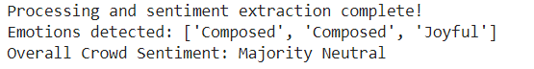

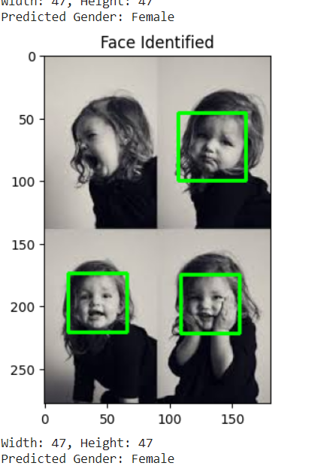

GitHub link